Project Design Phase-II
Data Flow Diagram & User Stories

Date | 3 October 2026
Team ID | SWTID-2026-3708
Project Name | Streamlining IT Procurement: Automating Standard Laptop Orders with Flow Designer
Maximum Marks | 4 Marks

Data Flow Diagrams:
A Data Flow Diagram (DFD) is a traditional visual representation of the information flows within a system. A neat and clear DFD can depict the right amount of the system requirement graphically. It shows how data enters and leaves the system, what changes the information, and where data is stored.
Data Flow Diagram (Level 1): Standard Laptop Order Automation
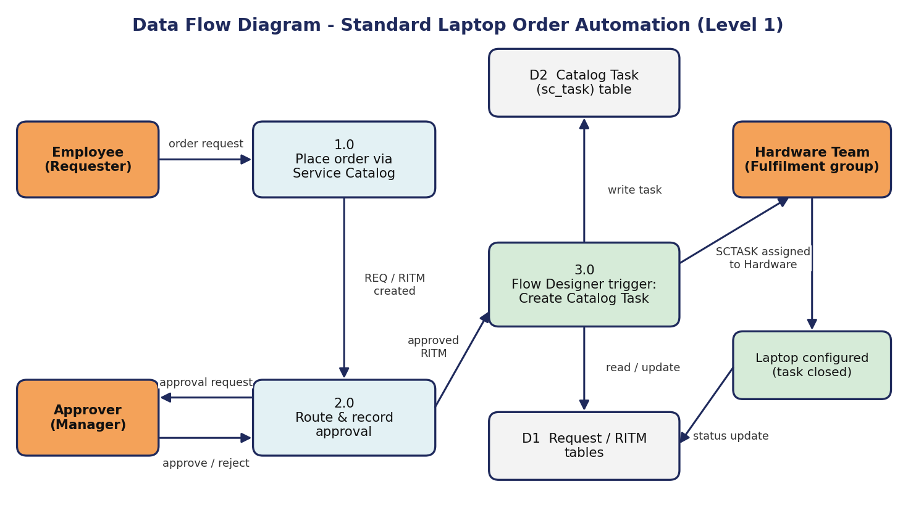

User Stories
Use the below template to list all the user stories for the product.
User Type | Functional Requirement (Epic) | User Story Number | User Story / Task | Acceptance criteria | Priority | Release
Employee (Requester) | Catalog Ordering | USN-1 | As an employee, I can browse Service Catalog > Hardware and open the 'Standard Laptop' item to view its specifications, price and optional software. | Standard Laptop item (Lenovo Carbon x1) is visible with specs and price | High | Sprint-1
 |  | USN-2 | As an employee, I can place my order by clicking 'Order Now', optionally choosing software. | Order Status page confirms submission and shows the Request number (REQ) | High | Sprint-1
 | Request Tracking | USN-3 | As an employee, I can open my Request and Requested Item to track progress of my laptop. | I can see the RITM and its catalog task status | Medium | Sprint-2
Approver (Manager) | Approval | USN-4 | As an approver, I can see the pending approval for the laptop request under the Approvers tab. | Approval record is in 'Requested' state against my name | High | Sprint-1
 |  | USN-5 | As an approver, I can approve or reject the request. | State changes to Approved / Rejected and is saved on the request | High | Sprint-1
IT Procurement Team Member | Flow Automation | USN-6 | As an IT procurement team member, I want tasks to be generated automatically and assigned to the Hardware team so that laptops are configured promptly on arrival. | A catalog task is created automatically for every Standard Laptop requested item | High | Sprint-2
 |  | USN-7 | As an IT procurement team member, I want the task to carry the short description 'Laptop needs to Configured' so the Hardware team knows what to do. | Short description and Description fields are populated on the task | High | Sprint-2
Hardware Team Member | Task Fulfilment | USN-8 | As a Hardware team member, I can see the catalog task assigned to the Hardware group. | SCTASK is listed under Catalog Tasks with Assignment group = Hardware | High | Sprint-2
 |  | USN-9 | As a Hardware team member, I can take the task, configure the laptop and close the task. | 'Assigned to' is updated and task state moves to Closed Complete | Medium | Sprint-3
Administrator | Flow Configuration | USN-10 | As an administrator, I can create the 'Standard Laptop task' flow in Flow Designer (Global application, run as System User) with a Service Catalog trigger and Create Catalog Task action. | Flow is saved and shows status Active | High | Sprint-1
 |  | USN-11 | As an administrator, I can attach the flow to the Standard Laptop catalog item under the Process Engine tab. | Flow field on the catalog item shows 'Standard Laptop task' | High | Sprint-1
 | Monitoring | USN-12 | As an administrator, I can review flow executions to troubleshoot failed runs. | Executions list shows the run with its status and step details | Low | Sprint-3

